***Bearing Mounts [1.0]***

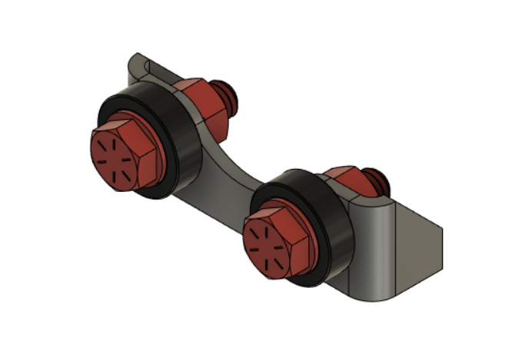

**Parts Needed**

**1x Bearing Mount Plate (Plasma cut)**

**2x 5/16” x 0.75” Bolts**

**2x 5/16” nuts**

**4x 5/16” SAE washers**

**2x 608 bearings**

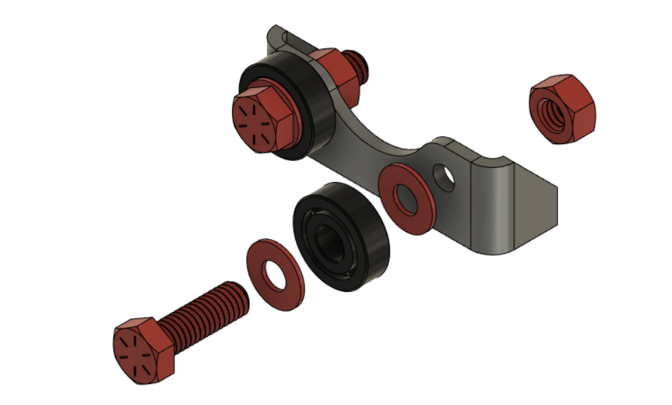

-Drill out holes so that 5/16” bolts will fit through

- Make 3 of these total